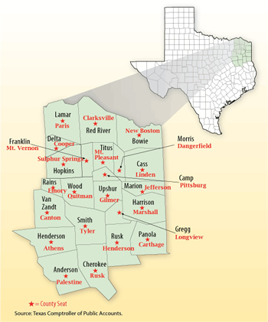
Figure: Texas in Focus: Upper East Texas. Texas Controller of Public Accounts Report (Combs, 2008).

